Brief report:

Implemented

1. Hemisphere sampling
   1. ant run -Dargs=scene/cbox-ao.xml
   2. 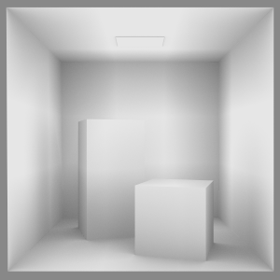
2. Ray intersection (accidentally provided)
   1. ant run -Dargs=scene/phong.xml
   2. 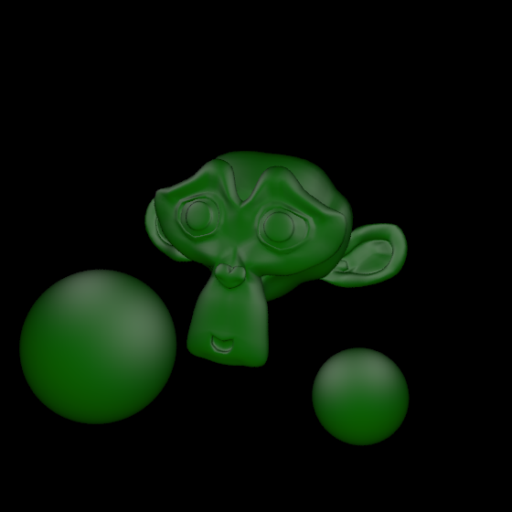
3. Direct path tracer
   1. ant run -Dargs=scene/cbox-direct.xml
   2. 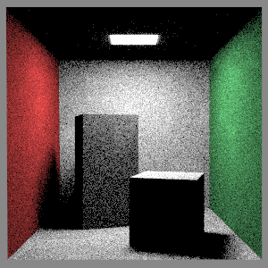
4. Recursive path tracer
   1. ant run -Dargs=scene/cbox-global.xml
   2. 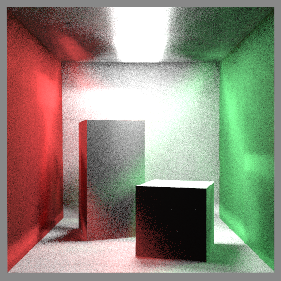
5. Russian Roulette recursive path tracer
   1. 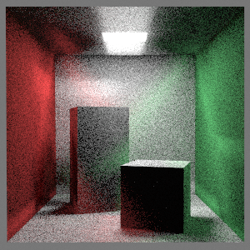
6. Texture mapping (bonus)
   1. Description
      1. Recreation of a solar system. 2 spheres and torus around a star.
      2. Implemented texture maps in TextureMaterial.Java
      3. Added texcoord conversion to obj2msh.py
   2. ant run -Dargs=scene/cbox-texture-submit.xml
   3. 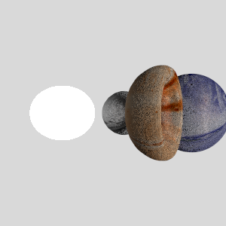

**Important Notes**

**Compiled with Java 13 but should work with Java 8**